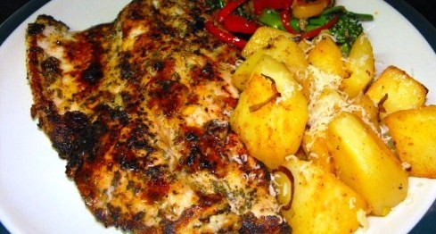

**Tilapia with Stir Fry Veggies & Pan Fried Potatoes**

* 1 Tilapia Fillet
* 1 Tsp Paprika
* 1 Tsp Garlic Powder
* 1 Tsp Dried Thyme
* 1 Tsp Black Pepper
* 1 Tsp Celery Salt
* Pinch Cayenne Pepper
* 1 Yellow Bell Pepper
* 1 Red Bell Pepper
* 1 Tsp sliced lemongrass
* 1 Tsp minced garlic
* 1/4 cup grated radish (optional)
* 1/4 cup leeks
* 6 Tbsp oil
* 2 Tbsp Thai Sweet Chili Sauce
* 2 large Potatoes
* Parmesan Cheese (optional)
* Lemon wedge (optional)

**Method:**

1. Mix first 6 ingredients in a zip loc bag with a splash of oil and set aside for about 20 minutes. If only cooking the fish skip to step #6
2. Meanwhile, peel some potatoes (or not if pressed for time), dice and par boil for 5 minutes. Drain and dry on kitchen towel.
3. While potatoes are boiling, julienne your peppers, lemongrass, mince the garlic and slice leeks (and grate Daikon if using)
4. In a medium skillet, heat oil on high heat and spread out potatoes in an even layer to pan fry them.  Do not turn them over until the bottom of potato turns golden brown. Season with salt & pepper and throw in leeks in the last minute of cooking.
5. In another skillet, heat two tablespoons oil on high heat, add garlic and lemongrass for 30 seconds, stir in the veggies and saute for about 2 minutes. Turn heat off and toss with Thai Sweet Chili Sauce.
6. In a large skillet, heat two tablespoons of oil on high and lay fish fillet away from you. Cook for about 3-4 minutes per side and serve with potatoes and veggies. You may squeeze some lemon over the fish for a fresh, zesty taste.

[source:](http://caughteating.wordpress.com/2011/09/14/blackened-tilapia/)